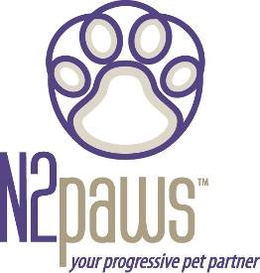
March / April 2006 Newsletter

I guess spring has officially arrived, but it is hard to tell since we had such a mild winter. Well, you know what that means? It means time for thunderstorms. It also means we will have a longer season of fleas and ticks.

Does your dog worry through Thunderstorms?
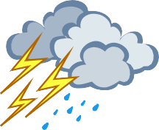
If the rumbling thunder in the distance makes your dog start pacing, whining, panting or hiding, then your dog would be a good candidate for some TTouch. If your dog doesn’t mind rolling
thunder but comes up off the floor several inches at a loud clap of thunder, then your dog would also be a good candidate for some
TTouch. TTouch can be offered through the gentleness of your hands, with slides and circle touches, or through the comfort of a body wrap or t-shirt. It is nice to have tools available to help your pooch get through a stressful situation.

You may do the gentle touches anytime that your pet is feeling stressed. If you use the wraps or t-shirt, ideally it would be good to use it a few times prior to storm season so that it doesn’t become associated with storms. You could put the wrap on your dog and engage him in a fun activity, such as a walk in the park (somewhere you don’t normally go), or have him follow you around for some tasty treats. This way he will associate the wrap with something rewarding and be glad to see it when you get it out for a storm.

Does your dog or cat scratch itself silly from fleas?
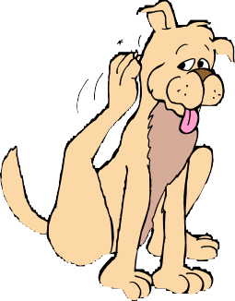
In our climate fleas and ticks present a problem each year. No one likes to see their dog or cat scratching. Especially, when your companion is allergic and may chew their skin raw turning into
hot spots. We all know there are products out there to prevent flea infestation. The products available for your yard
contain strong chemicals. While they will kill the fleas they also contaminate the grass - remember that your dog or cat may eat the grass where they have been sprayed, which could
lead to potential health risks. The flea and tick products that are
used on the skin may also cause allergic reactions. If your pets have experienced allergic reactions to applied flea products or if you are concerned about the risks of these products, there are alternative natural products that you can use. You may add a few drops of citrus extract to an organic/natural shampoo. Citrus is a natural flea repellent. You may make a powdered application of rosemary and diatomaceous earth (which kills fleas naturally as the compound actually breaks down the outer shell of the flea). There are some excellent natural products available (in either powder or liquid) that kill fleas. Contact me for more information on them.

Feature Companion for this issue: Sheba

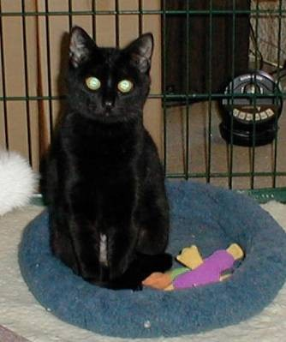
Sheba was picked up as a feral cat at about six months of age. She was very wild and scared. She was kept in a crate for the first few weeks, while she became acclimated to being inside and seeing people up close. She was given a warm place to sleep, good food, some toys, and plenty of patience and TLC. Over time people earned her trust. She eventually ate out of the hand that was gentle. She learned to use a scratching post and became the most lovable cat. You would have never known about her humble beginnings.

Just for Fun:

“The most affectionate creature in the world is a wet dog” – Ambrose Bierce

Upcoming Events for N2paws
April 8 & 9: TTouch class for dogs that fear storms, held at PetCo (135th & State Line), 12pm – 1:30pm (portion of proceeds go to PetCo Foundation, seating is limited)

April 29: Half-day TTouch for Dogs workshop in Midtown (KC) May TBD – Half-day TTouch for Dogs workshop in Liberty (NKC) June TBD – Half-day TTouch for Dogs workshop in Belton (SKC)

If you know anyone that would be interested in a “TTouch for Cats” workshop, have them contact pat@n2paws.com or 816-522-7005.

If you would like to learn more about TTouch, you may contact N2paws by email:
pat@n2paws.com or 816-522-7005, for a private session, group workshop or a public speaking engagement for your club or organization. Also, visit our website www.n2paws.com, for interesting links and current workshop schedule.

You are receiving this email from N2Paws because you attended a workshop, held a private session, or signed up on our mailing list. If you would like to continue to receive news updates from N2Paws (newsletters and scheduled events), then you need not do anything. If you no longer want to receive our news updates, then reply back to this email and replace the subject with “unsubscribe”, and your name will be removed.

