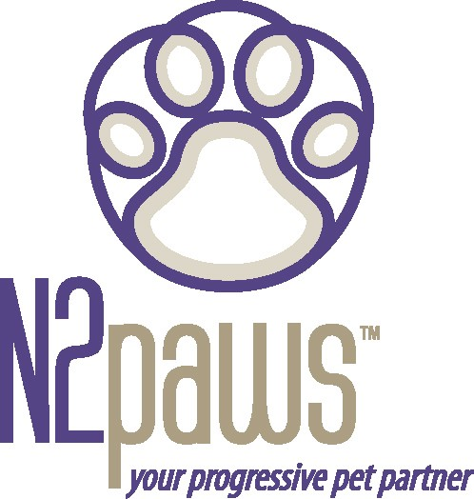
N2paws

January / February 2006 Newsletter
Greetings for 2006 – Wishing everyone a Happy New Year!!!!!! 2006 is the Year of the Dog in Chinese Astrology. Those born in the Year of the Dog are giving & compassionate, good listeners, and pay attention to their friends better than themselves. Does that sound like our four-legged “dogs”? So, 2006 is the year to celebrate our dogs!

Winter Tips
This newsletter comes to you during the winter months. Even though this winter has been very mild so far, it is the time of year that we normally have cold weather and snow. We must be mindful of the temperature when our pets go outside. Just because they have fur doesn’t mean they can tolerate lengthy play
time in the cold outdoors. Think of the amount of time you would want to be outside in frigid temperatures, even while wearing a coat. Dogs with very short hair are more susceptible to hypothermia; it would be like you being outside in the cold in a t-shirt. Animals lose most of their body heat from the pads of their feet, their ears, and through respiration, so it’s best to keep an eye on them when they are outside.

You also need to consider your pet's health when deciding how long to leave her out. Conditions like diabetes, heart disease, kidney disease, and hormonal imbalances can compromise your dog or cat’s ability to regulate her own body heat. Animals that are not in good health shouldn't be exposed to winter weather for
long periods of time. Young pups or kittens and our geriatric companions are vulnerable to the cold as well. Also, pay attention to arthritic pets during the winter months. Their joints can get stiff and be extremely tender, which you may notice as awkward movement and limping. TTouch would be a good remedy for your arthritic companion, especially during the cold season.

The other thing to be mindful of is where your pet walks during winter strolls. The snow & ice removal formulas (pellets & salt), can be toxic to your pet. In general I recommend against using these products; there are products that indicate they are safe (i.e.
Safe Paws). Unless your dog or cat only stays in your yard, then you won’t know what they have been exposed to, since you can’t control what your neighbors use and what the city dispenses. The safest thing to do is to thoroughly wash your pets feet when they come in from a winter outing. You could keep some towels or rags and a jug of water by the door for wiping feet.

If you don’t get the chemicals off of their feet they can not only harm the skin, but get licked off and irritate the digestive system or be absorbed through the skin and cause other health issues. You can go out and have fun romping in the snow with your pet and keep them safe too.

Feature Companion for this issue: Workshop Dog

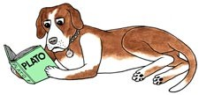
Want to teach your dog to think or learn to focus? Attend a TTouch workshop. N2paws held the first workshop in the Kansas City northland in January! I’d like to thank VSI for hosting, with an excellent venue. N2paws looks forward to more workshops in Liberty.
The Border Collie Rescue Group had several participants, along with a couple of Aussies and a gentle giant Newfoundland. It is as interesting to see the differences in the same breed, as it is observing a variety of breeds. Every workshop brings a new learning experience (for the people and the dogs).

Just for Fun:

Check out the new N2paws logo in future editions of Paw Prints or Kansas City Wellness publications (starting in March).

In honor of the upcoming winter Olympics:
“Life is like a dog sled team. If you ain’t the lead dog, the scenery never changes” – Lewis Grizzard

Upcoming Events for N2paws February 19: Half-day TTouch for Dogs workshop in Belton, MO. March 18: Half-day TTouch for Dogs workshop in Midtown (KC)

If you would like to learn more about TTouch, you may contact N2paws by email:
pat@n2paws.com or 816-522-7005, for a private session, group workshop or a public speaking engagement for your club or organization. Also, visit our website
www.n2paws.com, for interesting links and current workshop schedule.
You are receiving this email from N2Paws because you attended a workshop, held a private session, or signed up on our mailing list. If you would like to continue to receive news updates from N2Paws (newsletters and scheduled events), then you need not do anything. If you no longer want to receive our news updates, then reply back to this email and replace the subject with “unsubscribe”, and your name will be removed.

