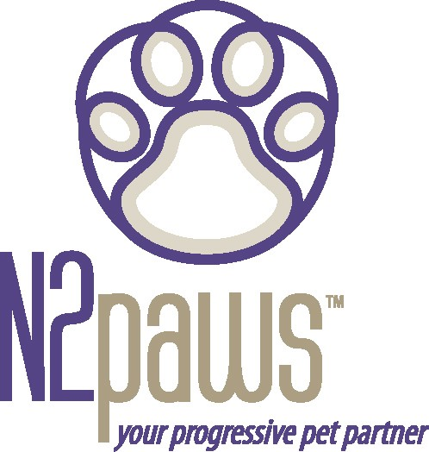
Animal Attunement

September / October 2005 Newsletter
Lots of things going on this fall!
I would first like to take a moment to recognize the wonderful work going on in the animal rescue community to help those animals that survived the disaster on the gulf coast. If you have the time to volunteer or the means to make a donation, several local area shelters and groups are collecting to support the effort, Sunflower Humane Society, Wayside Waifs, & Puppy’s Playpen to name a few. Also, two wonderful national organizations have done a lot to provide animal rescue support to the gulf coast: Best Friends
(www.bestfriends.org) and Noah’s Wish (w ww.noahs-wish.org). If you want
to see Katrina from the animals’ perspective – take a look, but grab a tissue and give your cat or dog several long gentle strokes and tell them how much you love them: www.forpitssake.org/katrina.html.

The greatness of a nation and its moral progress can be judged by the way its animals are treated.. – Mahatma Ghandi.

On to some brighter news…….N2PAWS sponsored Kathy Cascade,
Tellington TTouch Instructor, for a weekend workshop in September. Kathy’s background in physical therapy and her creative and humorous teaching style made for a fun time for the people and a good learning experience for the dogs. I hope to bring her back again next year. So, if you know anyone who would be interested in sharing their weekend with their dog and learning some new techniques, tell them to get in touch with me and we’ll get a date set.

Feature Companions for this issue:

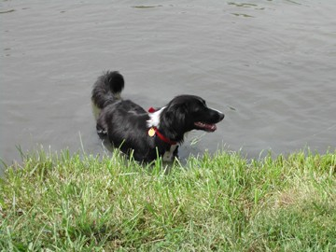
Annie – Border Collie (BC). Annie was a rescue from the Border Collie rescue group. She needed help with her socialization skills when she came to her forever home. She would show aggressive tendencies toward other dogs and chase the cat. Through TTouch, lots of love and TLC, and patience from her guardians, she has adjusted to her home, to people, other dogs and the cat. Her latest accomplishment was attending a BC doggie party where she ran and played with the other dogs and even got in the water! Bravo to Annie.

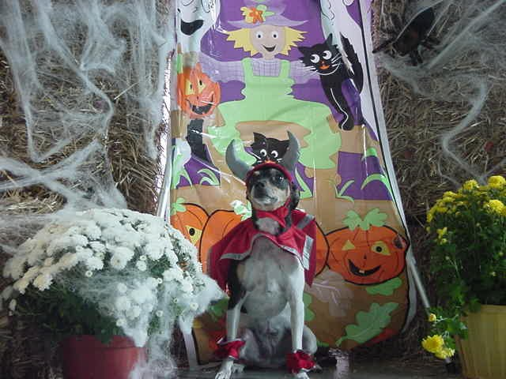
Spunky – Rat Terrier. Spunky truly lives up to her name. She is full of energy and wants to share it with you. She needed some calming from her bounciness and vocalization. Through her TTouch lessons she learned what it was like to be in her body, become focused, and become calmer. She now has tools she can use to remind her of calm. But today she wants to show you the devilish side of her. She thought it would be appropriate, since October is just around the corner. Boo – from Spunky

If you have an update on your companion animal, I would love to hear it. Send it in - and your dog, cat, or bird could be featured in the next issue.

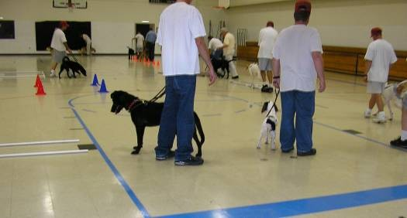
N2PAWS made a presentation to the
Safe Harbor Prison Dog Program participants. This was a unique opportunity for both N2PAWS and the
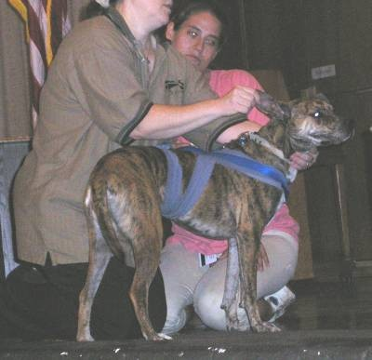
prison dogs and handlers. It gave the
handlers some new tools and techniques to use with the dogs and will give the dogs some new lessons to learn. N2PAWS was proud to have the
opportunity to work with this program. It brings not only new learning experiences to both the dogs and the handlers, but a deeper sense of connectivity and pride, which will translate into calmer dogs for the new adoptive guardians. Check out the program at www.safeharborprisondogs.com.

Upcoming Events for N2PAWS

October 1: Strutt with your Mutt 10am – 4pm at Brookside
Go to www.waysidewaifs.org for more information or to register

October 16: Dogtober Fest 10am – 4pm at Lake Jacomo / Kemper Outdoor Education Center Fleming Park
Go to www.jacksongov.org for more information or to register

If you would like to learn more about TTouch, you may contact N2PAWS by email:
pat@n2paws.com or 816-522-7005, for a private session, group workshop or a public speaking engagement for your club or organization. Also, visit our website
www.n2paws.com, for interesting links and current workshop schedule.
You are receiving this email from N2Paws because you attended a workshop, held a private session, or signed up on our mailing list. If you would like to continue to receive news updates from N2Paws (newsletters and scheduled events), then you need not do anything. If you no longer want to receive our news updates, then reply back to this email and replace the subject with “unsubscribe”, and your name will be removed.

