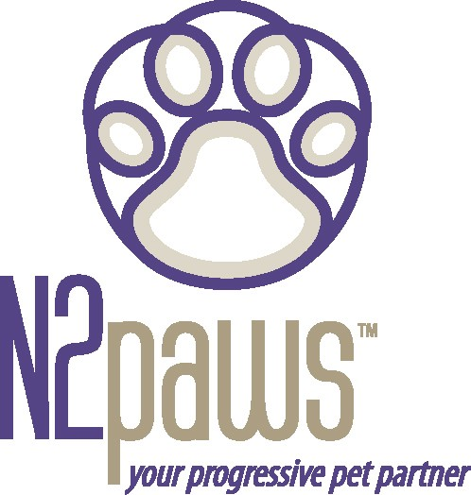
Animal Attunement
September / October 2005 Newsletter
Are you ready for the holidays???
This is a good time of year to be thankful for the companionship of our furry and feathered family members. A good way to remember your pets is to offer them something rewarding that you don’t normally do, such as going to a dog park if you normally go on walks in your neighborhood, or give them some extra special time like setting aside a weekly half hour play session with a favorite toy (squeaky ball or catnip toy on a string). Another nice reward for both you and your pet, during the (sometimes stressful) holiday season, would be a few minutes of daily mindful gentle touching (TTouch ear slides, long strokes down the body and certainly the circle TTouches). These touches will enhance bonding and relieve stress for both of you (your stress and the stress they feel from your emotions or tension).

Other things to consider during the holiday season for your 4-legged and winged companions, are the logistics of the holidays. They could use some extra TLC during this period:

- If you will be traveling, whether they travel with you or are boarded, TTouch can provide a calming effect for the stress of travel.

- If you will be hosting guests in your home, providing them a “safe” place to go so that they are not overwhelmed with the excitement or the stress (then be sure to include some TTouch before, during and after the visit to bring the excitement or stress level down and bring them back in balance).

- If they will be around small children (especially if not accustomed to it), ensure that they are supervised in the presence of children and have that “safe” place to go when they need some space. This will secure the safety of your pets and the children.

- If they are begging you for holiday treats, make sure you have something nutritious to offer as you spoil them. Human foods can be dangerous to them, such as sweets (especially chocolate or raisins), or bones from a turkey (can splinter). Other human foods can be just too rich for their digestive systems. You could consider setting aside some healthy trimmings as you prepare the food, to offer as treats:
  - a piece of cooked sweet potato before the glaze is added
  - some scraps of meat when you debone the turkey,
  - a few cooked green beans prior to making the cassarole
Your pet will feel included in the festivities and you won’t be adding any risk to their health.

Feature Companion for this issue:

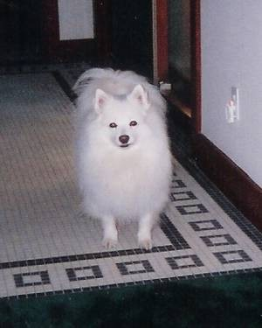
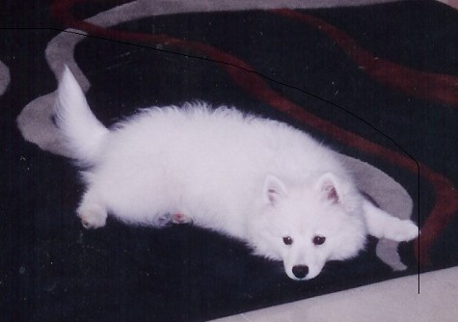
Angel – American Eskimo (miniature). Angel is a sweet girl that has had her share of stress both physical (TPLO surgery, alopecia (a skin disorder), and
an adrenal growth) and mental (loss of a sibling). With some holistic and medical treatment, as well as
lots of love and TLC, she is on the rebound. TTouch was a nice introduction into her regime and brought her new ways to calm and cope with the stress from her physical issues. As Angel continues on her journey, lighting up a room when she enters, she lives
up to her name and what a great feature dog for the holiday season.

Just for Fun:
If you take digital pictures and you want to make your companion animal a celebrity for the holidays, check out this website (sign up and get 20 free prints): http://www.dgregory1.myphotomaxusa.com. You can celebrate your pet on a mug, tote bag, deck of cards, puzzle, etc. You can also make a DVD movie of your companion and she might be the next Lassie or he might be the next Morris.

“My dog is worried about the economy because Alpo is up to $.99 a can. That’s almost $7.00 in dog money.” – Joe Weinstein

Upcoming Events for N2PAWS
No workshops will be held in November or December due to everyone’s busy holiday schedule. Workshops will resume in January (Liberty will be rescheduled from Nov.)

If you would like to learn more about TTouch, you may contact N2PAWS by email:
pat@n2paws.com or 816-522-7005, for a private session, group workshop or a public speaking engagement for your club or organization. Also, visit our website
www.n2paws.com, for interesting links and current workshop schedule.
You are receiving this email from N2Paws because you attended a workshop, held a private session, or signed up on our mailing list. If you would like to continue to receive news updates from N2Paws (newsletters and scheduled events), then you need not do anything. If you no longer want to receive our news updates, then reply back to this email and replace the subject with “unsubscribe”, and your name will be removed.

