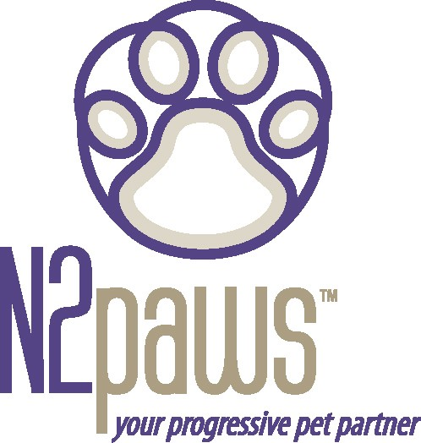
Animal Attunement
May / June 2005 Newsletter

Upcoming Events for May & June: May
Kansas City is hosting its first Pet Expo! This exciting event will be at the American Royal Center and is a benefit for the humane organizations of greater Kansas City.
May 13 – 15th. Fri. & Sat. 10am - 8pm, Sun. 10am – 5pm

There will be a lot of fun things to see at the Pet Expo. The dog & fish area includes:
- Walk of Breeds (where you can learn about all the different breeds)
- Human organizations & rescue groups (e.g. Human Society of Greater KC, Wayside Waifs, Animal Haven and more)
- Incredible Dog Team
- Canine Freestyle Association
- Dog Stage (for demos – I will demo TTouch a few times throughout the weekend).

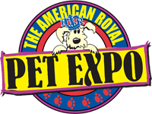
The cat, bird & reptile area includes:
- Cat Breeds
- Cat Show, including Cat Agility :)
- Winter Garden Society
- Reptile Stage

The large animal area is in Hale Arena and will feature equestrian activities.

They are offering $1.00 off each ticket at the door if you have a Price Chopper card. Note: the attending public is not allowed to bring animals to the Expo.

June
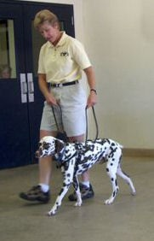
N2PAWS is sponsoring a TTouch weekend
workshop with one of the TTouch program instructors: Kathy Cascade. Kathy is a graduate of the first TTouch certification course given in 1996. She has a creative and humorous teaching style, making for a very fun class :). Kathy is a licensed physical therapist with extensive experience in neurological disorders and rehabilitation. This experience translates very effectively into the TTouch world of working with animals.
Workshop info:
- June 4th & 5th
- Man’s Best Friend in Belton
- Register through N2PAWS: pat@n2paws.com
- Don’t miss this opportunity!!!!!!

Also, in June is an Introduction to TTouch, 5-day course in St. Louis (6/25 – 6/29). It is the introductory course that will provide you an overview of the TTouch techniques and tools. It also qualifies as the first class in the 2-year certification program. If you are interested in taking this course, you may register at
www.ttouch.com, code: PAHEMO.

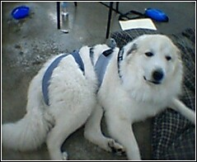
Reminder: If your dog is afraid of fireworks, start using that body wrap or t-shirt in June so that he/she gets used to it before the 4th of July. Also, circle touches all over the body will help calm and relax the nervous system.

If you would like to learn more about TTouch, you may contact N2PAWS by email:
pat@n2paws.com or 816-522-7005, for a private session, group workshop or a public speaking engagement for your club or organization. Also, visit our website
www.n2paws.com, for interesting links and current workshop schedule.
You are receiving this email from N2Paws because you attended a workshop, held a private session, or signed up on our mailing list. If you would like to continue to receive news updates from N2Paws (newsletters and scheduled events), then you need not do anything. If you no longer want to receive our news updates, then reply back to this email and replace the subject with “unsubscribe”, and your name will be removed.

