Animal Attunement

March / April 2005 Newsletter

Is Your Dog Afraid of Loud Noises (Thunderstorms)?
It is fairly common for dogs to be afraid of loud noises, like fireworks or thunderstorms. And since we are fast approaching that time of year when the rains begin to fall and thunderstorms are upon us, I thought I would dedicate this newsletter to the topic of “fear of loud noises”. When you hear the rumble of thunder in the distance, do you have to calm your dog, turn the volume up on the TV, go find your dog burrowed in the back of the closet? If so, then TTouch may just be the answer for you to help your canine friend.

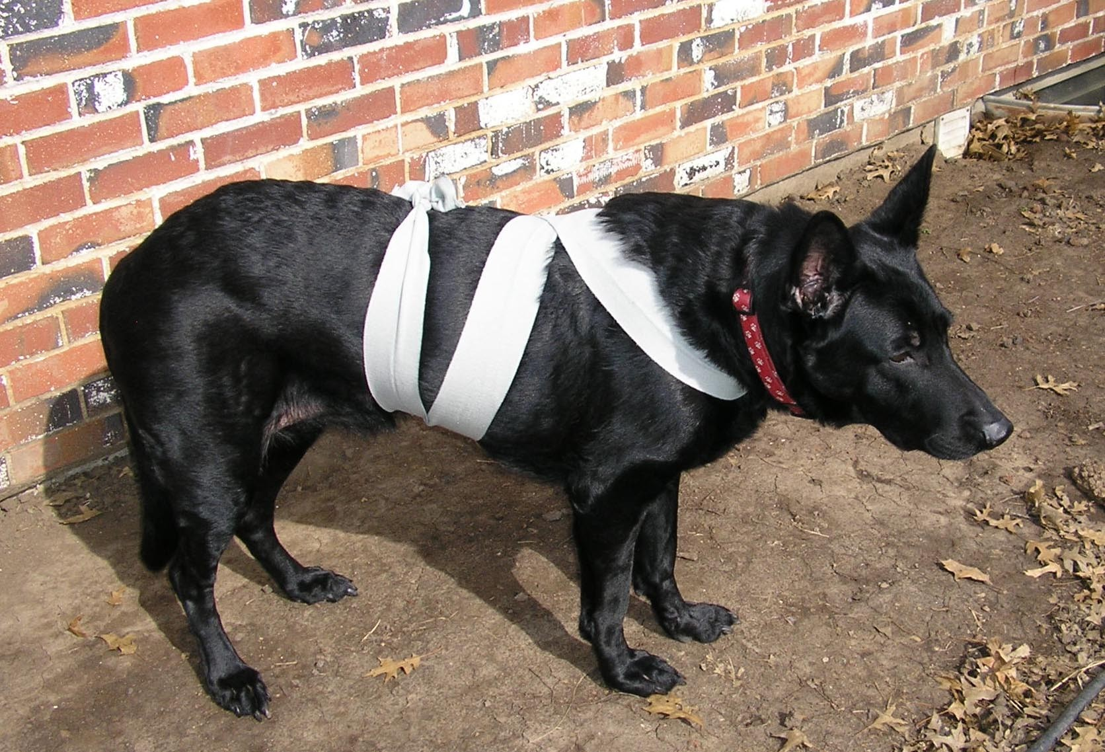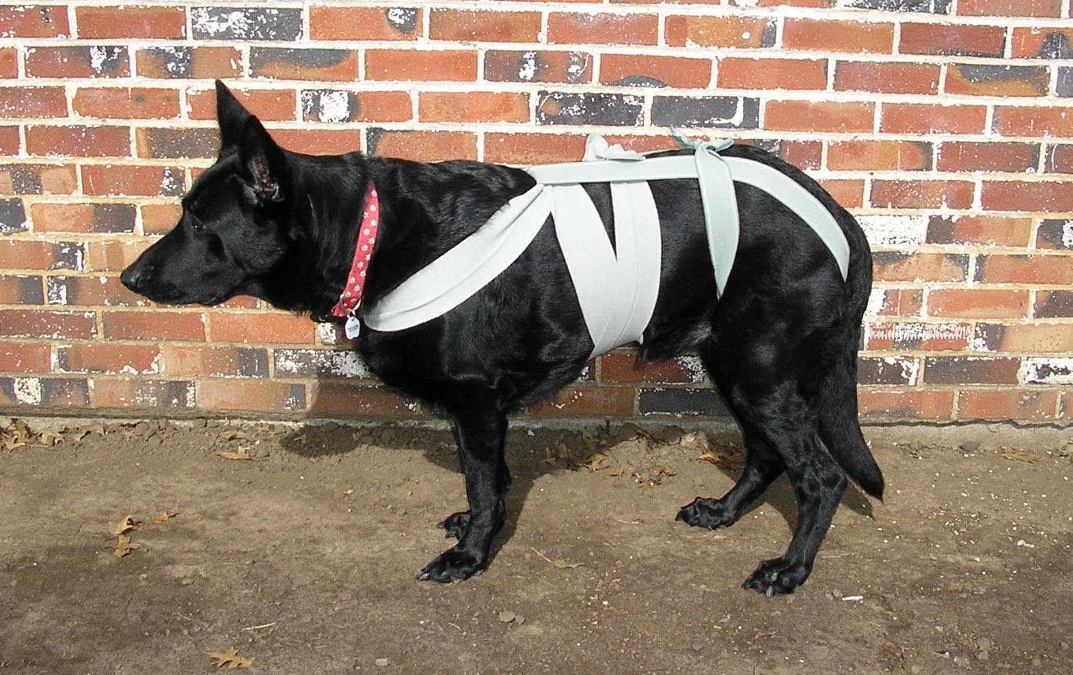TTouch is a respectful method of working with your dog, using gentle touch and movement, to bring your dog into balance both physically and emotionally. TTouch (short for Tellington TTouch) was developed by internationally known animal expert Linda Tellington-Jones thirty years ago, as a technique to help animals overcome physical and behavioral issues. It is used to enhance health, modify behavior, improve performance, and deepen relationships.
Animals respond to fear with the “fight or flight” reaction, which pumps adrenaline, tightens muscles, and sends signals throughout the nervous system. What the Tellington TTouch method does is provide information

to the nervous system through light touches and focused movements and the use of body wraps (as seen in the photos). These techniques allow the nervous system to process the touches received (through the hands or wrap), as information, and to adjust accordingly. Therefore, the TTouch approach can help with the fear of loud noises as well as many other types of fears (going to the vet/groomer, other dogs, people/strangers, going into the show ring, etc.).
The TTouch techniques can be used at home, at the dog park, in the car, at a dog show, or most any place that you can be with your dog and apply some focused touch and attention. TTouch methods are best applied at a variety of times prior to an event that triggers fear, vs. right before the event (e.g. 2-3 times a week prior to a vet visit or dog show vs. right before entering the vet’s office or show ring, 2-3 times a week prior to the anticipation of thunderstorms vs. when you hear the rumble of thunder in the distance). The reason for this is so your dog has time to process the TTouch information and not associate the TTouch techniques to the event that triggers fear.

The TTouch techniques have been studied scientifically, through measuring brainwave patterns, and have been found to not only relax the subject (your canine companion), but to have a relaxing affect on you as well. If you would like to learn more about TTouch, you may contact N2Paws by email: pat@n2paws.com or 816-522-7005, for a private session, group workshop or a public speaking engagement for your club or organization. Also, visit our website www.n2paws.com, for interesting links and current workshop schedule.

You are receiving this email from N2Paws because you attended a workshop, held a private session, or signed up on our mailing list. If you would like to continue to receive news updates from N2Paws (newsletters and scheduled events), then you need not do anything. If you no longer want to receive our news updates, then reply back to this email and replace the subject with “unsubscribe”, and your name will be removed.

