Animal Attunement
July / August 2005 Newsletter

Summer Fun with your Dog!
Are you one of those people that just loves to get out during summer and do fun activities with your dog? Maybe go to the dog park and throw a frisbee or tennis ball around? How about agility workouts? Ok, so maybe you just like to sit on the park bench at the dog park and read your paper while your canine companion runs with the pack. It still means your dog is getting a workout. Well, I have some TTouch tips for you!

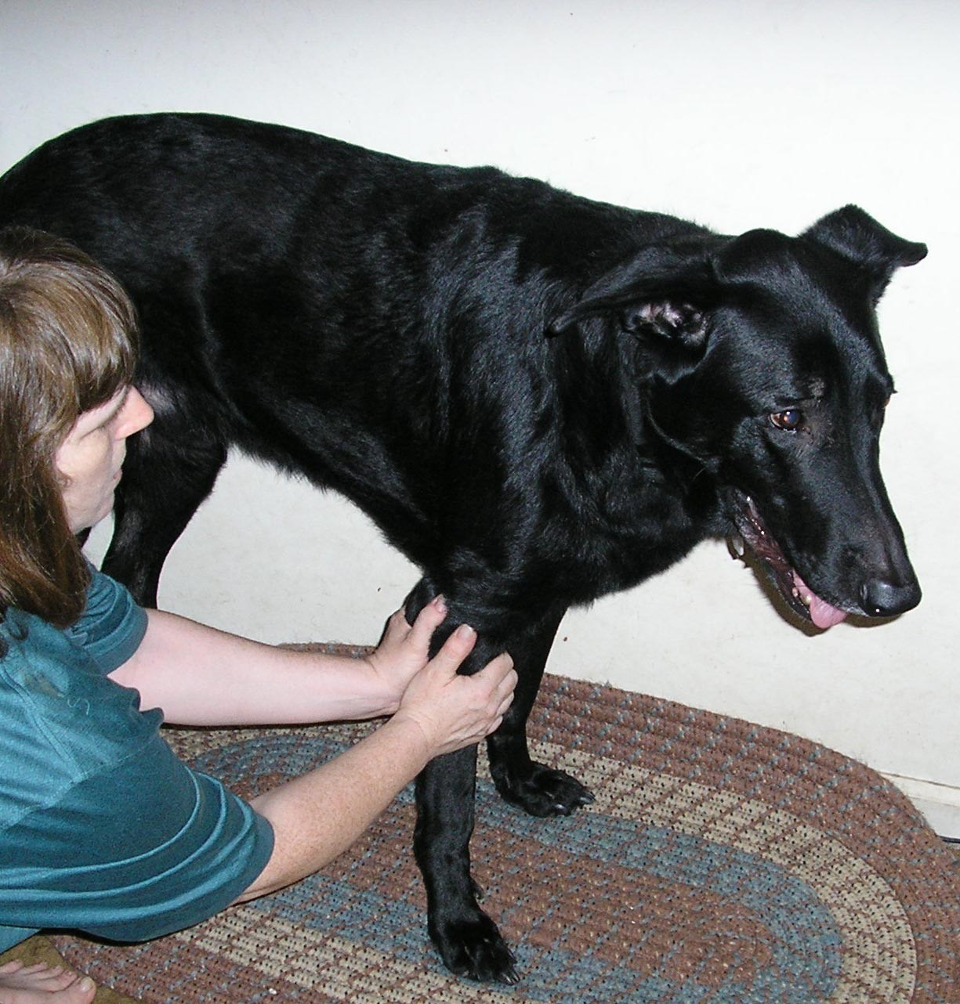
If you have a dog that’s active, it is good to give him a little TTouch warm up before he goes out to play and a little when he comes If home after he cools down. your dog is doing a lot of jumping, which stretches the leg muscles and puts pressure on the joints, then TTouching the legs with “python lifts” would be good. Remember
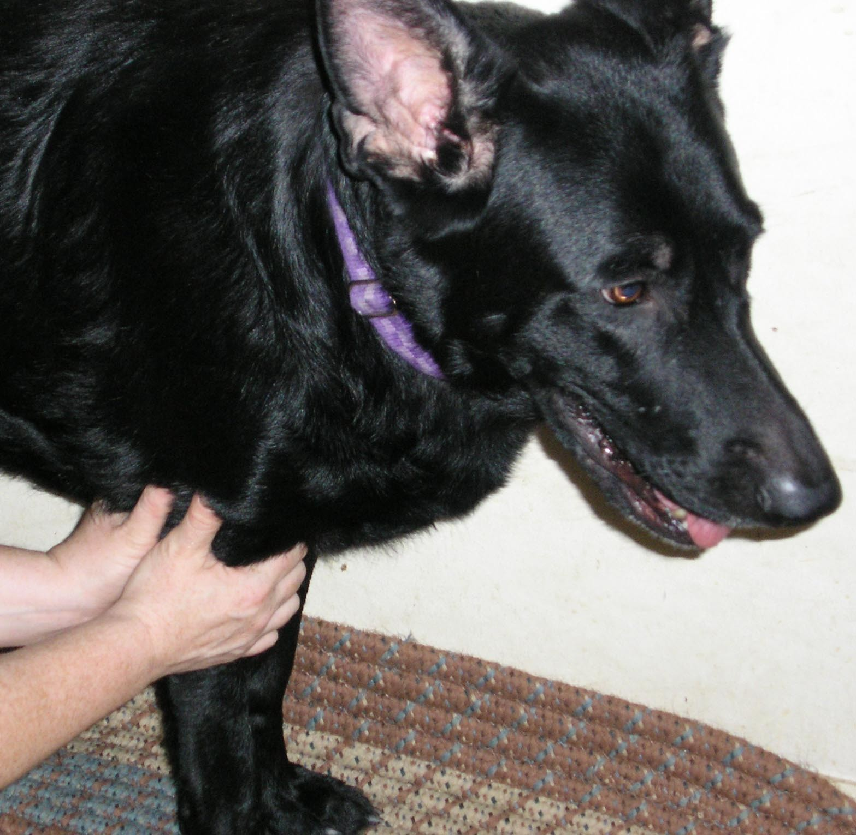
these are VERY light gentle touches where you are sliding the skin, holding it for a few seconds and slowly allowing
the skin to come back to where you originally placed your hands. You start at the top part of the leg and work down to the ankle, then gently glide your hand off the paw. You can do this while your dog is standing or lying down, and work each leg one time.

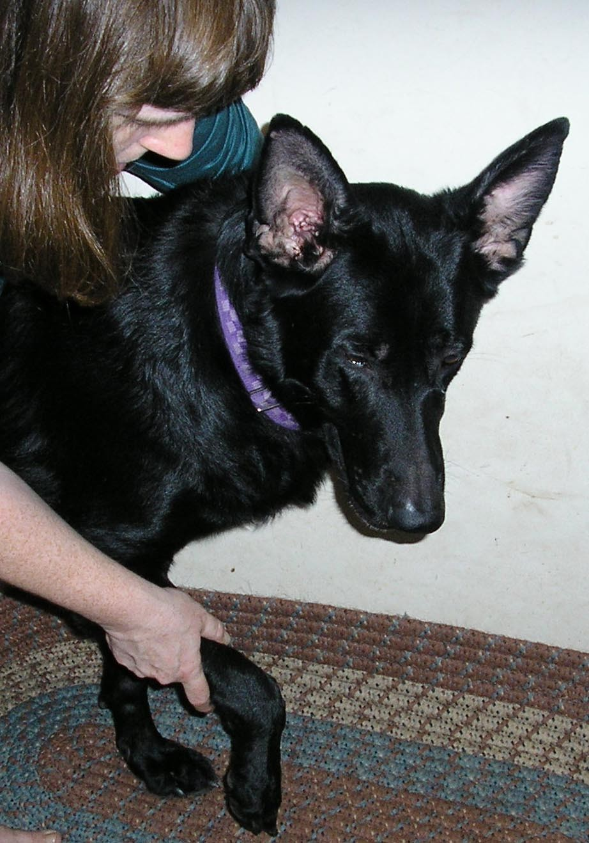
Another good TTouch for your active dog is leg circles. You can also do this TTouch while your dog is standing or lying down, and work each leg one time. If your dog is standing, you gently lift one leg holding it in about the center of the leg. You then

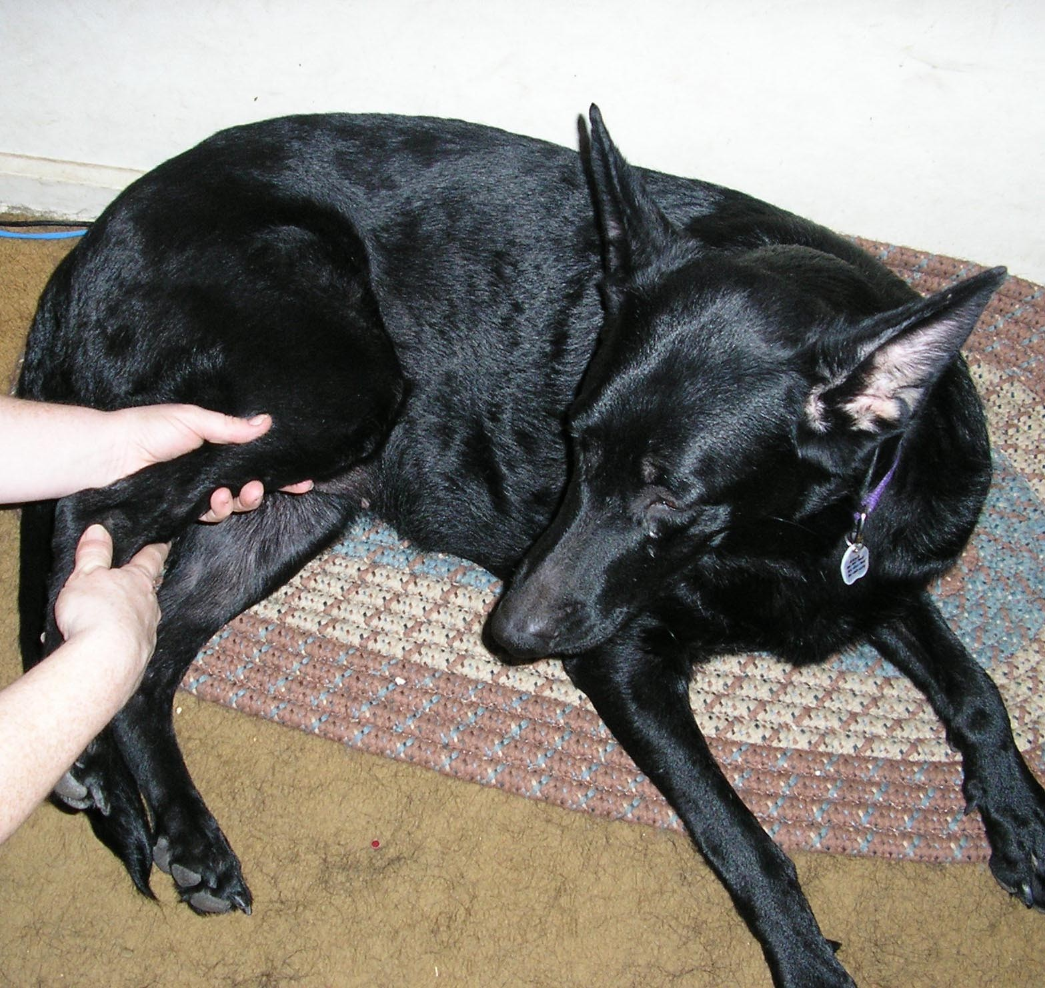
move the entire leg in 3 tiny circles one direction then 3 tiny circles in the opposite direction (as if the paw was a pencil and you were drawing the circles on the ground). If your dog is lying down, you make the circles in the air. You will feel the movement in the shoulder, but these are very small circles (very minimal rotation).

For your active dog, you can do these touches before activity and again after your dog has cooled down (maybe an hour after the activity). If your dog is not very active due to health or age, these leg lifts and leg
circles would be good touches to do periodically. It will help her even for a slow walk or just a trip out in the yard. These touches help to remind your dog about being balanced and make her feel more grounded. When your dog is balanced physically, she will be balanced mentally and emotionally.

Remember, while you enjoy your fun in the sun, that your dog can become overheated. Early in the day is a good time for outdoor exercise – before it gets too hot and less mosquito activity ☺.
Always have water available for your dog when playing or exercising and take breaks frequently in shady spots (take extra breaks if your dog is black or has a thin coat).

I think we are drawn to dogs because they are the uninhibited creatures we might be if we weren’t certain we knew better. – George Bird Evans.

If you would like to learn more about TTouch, you may contact N2Paws by email:
pat@n2paws.com or 816-522-7005, for a private session, group workshop or a public speaking engagement for your club or organization. Also, visit our website
www.n2paws.com, for interesting links and current workshop schedule.

You are receiving this email from N2Paws because you attended a workshop, held a private session, or signed up on our mailing list. If you would like to continue to receive news updates from N2Paws (newsletters and scheduled events), then you need not do anything. If you no longer want to receive our news updates, then reply back to this email and replace the subject with “unsubscribe”, and your name will be removed.

